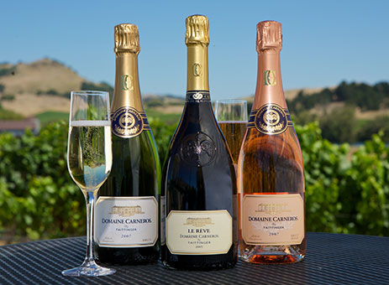

IAOTP IN WINE COUNTRY

Come Join IAOTP members for a weekend touring Napa and Sonoma Wine Country:

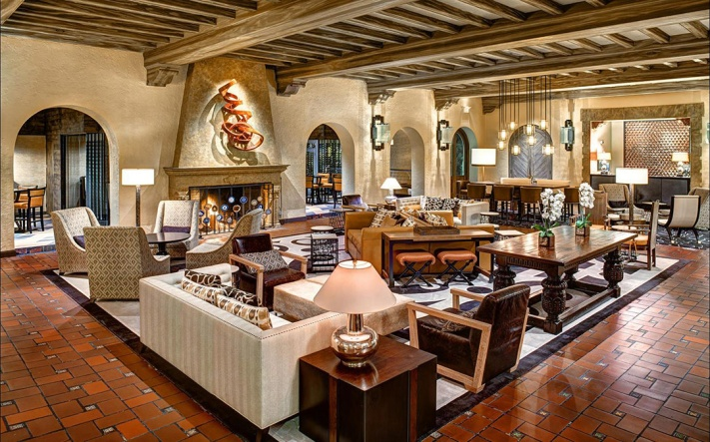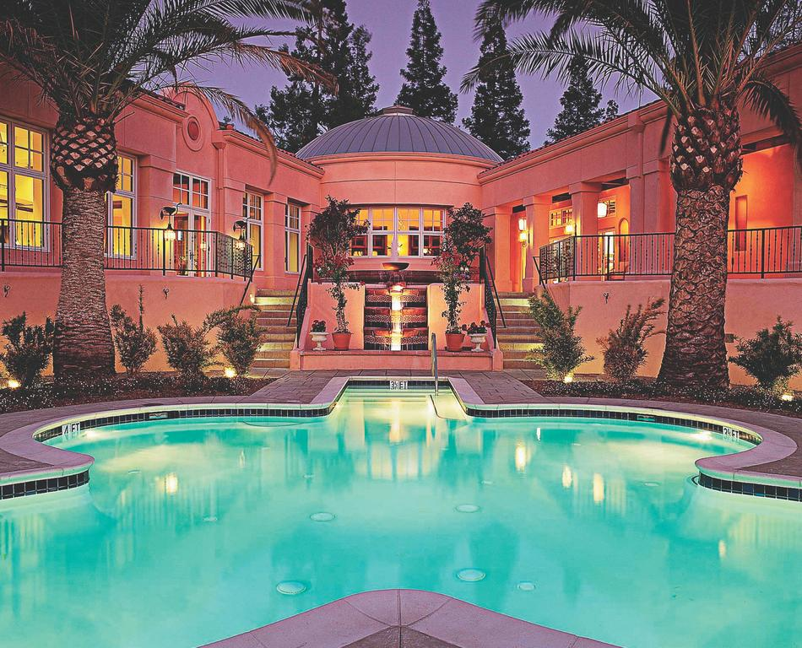

CHECK IN BEGINS 4pm Thursday June 27th

6:30-8:30 Welcome Reception in the Tower Room & Patio
Entertainment by Dr. David Hardiman’s Jazz Ensemble

Cocktails and Stations

Sonoma Mission Inn Resort and Spa
Greeted with Sparkling Wine at Check in
Welcome Reception sharp 630pm

Friday June 28th 8-9 am Hot Signature Breakfast on the Creekside Lawn at Sonoma Mission Inn

9:30am Bus to take Members Tour of the Space Station Museum (Ken Winans Museum)

12pm Rams Gate Winery for Lunch and Wine Tasting
Keynote Speech Ken Winans

330pm Domaine Caneros Vineyard Tasting and Tour
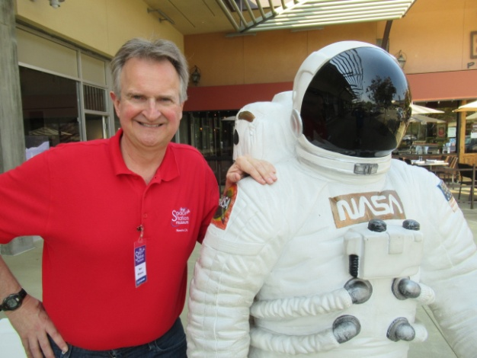
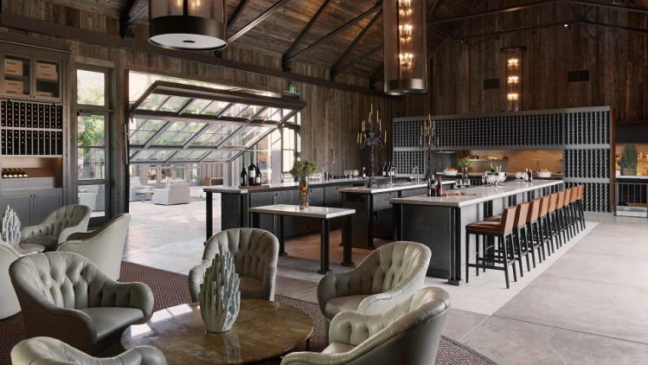

For Friday night people can have free time to sight see, book a spa,
Make a reservation at Sante Restaurant
Saturday June 29th

8-9 am Hot Signature Breakfast on the Creekside Lawn at the Hotel
Chartered Bus pick up at Sonoma Mission Inn 9:30 am to take members to

10:30 am B R Cohn Winery and Olive Oil Company
Tasting 4 Current Release Wines

12 pm Ledson Winery for Lunch 60 min tour and 7 Tastings

230pm Chateau St. Jean Tasting and Tour last tasting is at 4:00pm.

Private Reserve Wine Tasting:

Enjoy a selection of Chateau St Jean Reserve wines while your host takes you on a journey through Chateau St Jean’s history and philosophy of wine making.
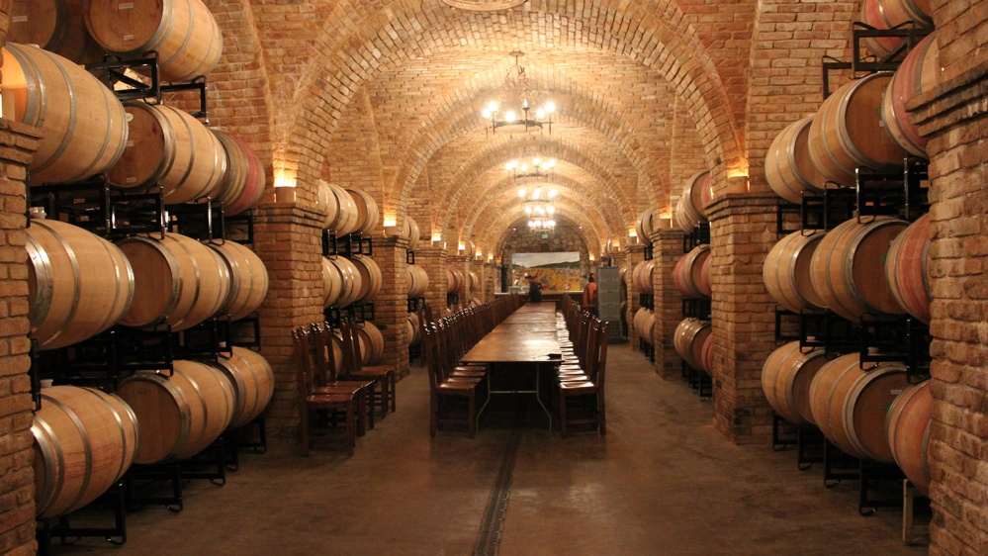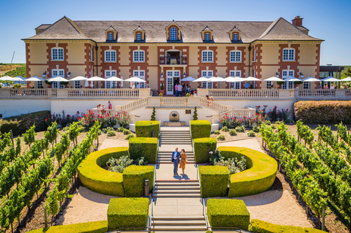
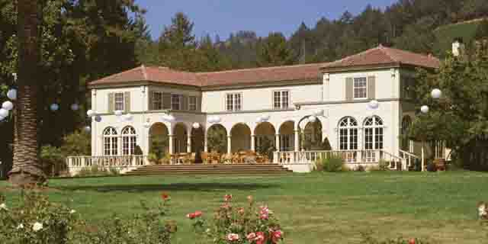

SATURDAY NIGHT
6pm Members are booked for a formal dinner and closing of IAOTP Weekend
Sante Restaurant on the Private Patio
SIGHT SEE, HAVE DINNER, EXPLORE THE HISTORIC SONOMA TOWN
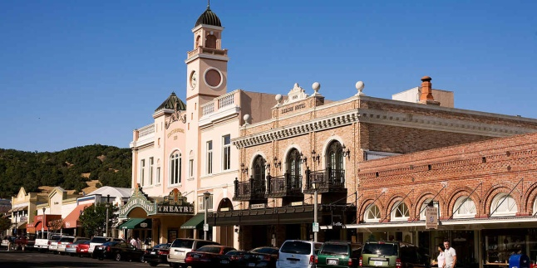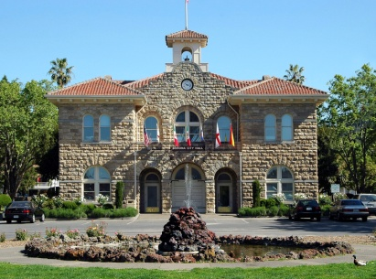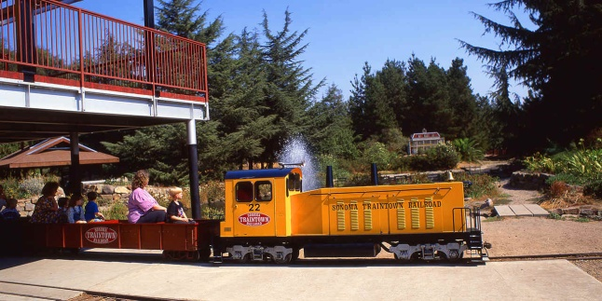

SUNDAY JUNE 30TH
CHECK OUT AT 11AM.

