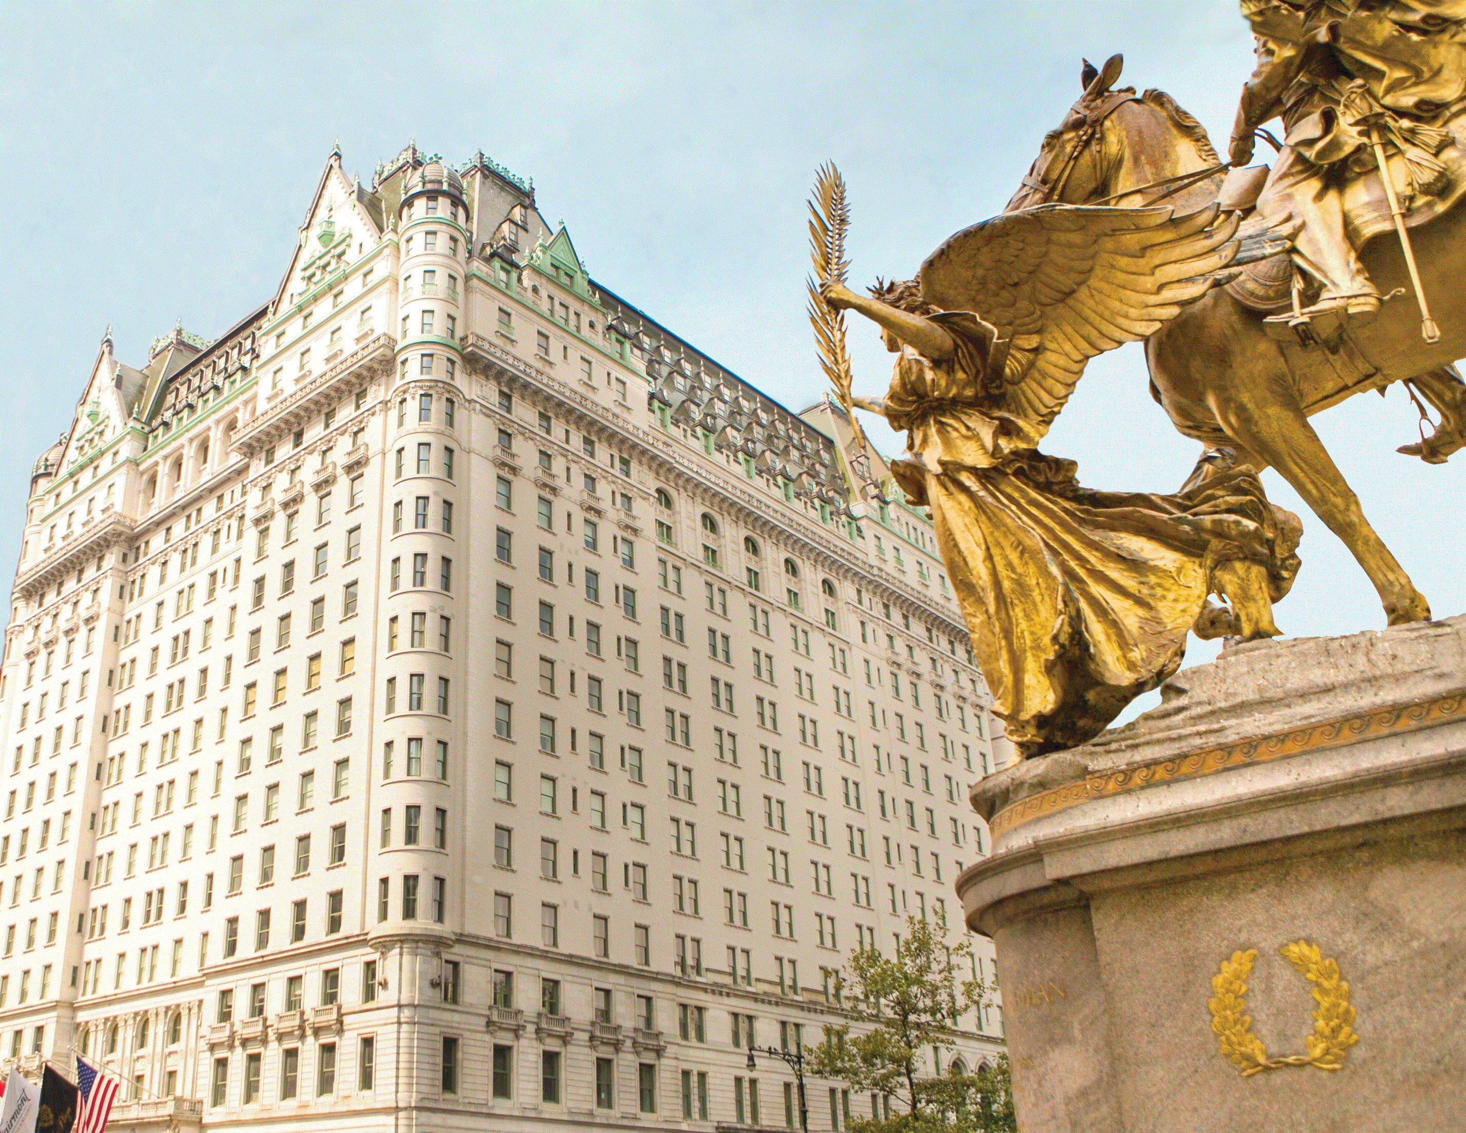

GALA PACKAGES

**NYC ROYALTY PACKAGE**

**$19,999**

INCLUDES:

TABLE OF 10 AT THE GALA NYC GRAND PLAZA BALLROOM, BLACK TIE AFFAIR, COCKTAIL PARTY, FORMAL SIT DOWN DINNER, AWARD CEREMONY, ENTERTAINMENT

NYC TIMES SQUARE BILLBOARD DEBUT ON NASDAQ

2 FULL PAGE ADS IN TIP MAGAZINE SPECIAL GALA EDITION

LOGO ON SCREENS AND STEP AND REPEAT/MENTIONED THROUGHOUT THE NIGHT AS SPONSOR

3 NIGHTS KING PLAZA HOTEL GUESTROOM THURS NOV 30TH-SUNDAY DEC 3RD

BOTTLE OF CHAMPAGNE

RED CARPET PHOTOSHOOT

VIP PASSES FOR THE WEEKEND

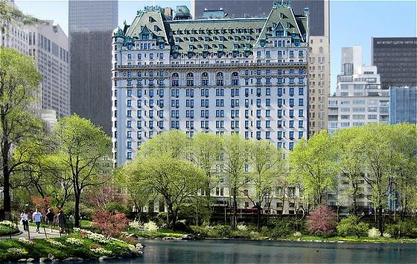

**PLAZA PACKAGE**

**$11,999**

INCLUDES:

4 TICKETS TO THE NYC PLAZA GALA GRAND BALLROOM, BLACK TIE COCTAIL PARTY, FORMAL SIT DOWN DINNER, AWARD CEREMONY AND ENTERTAINMENT

1 FULL PAGE AD IN TIP MAGAZINE SPECIAL GALA EDITION

NYC TIMES SQUARE BILLBOARD DEBUT ON NASDAQ

PHOTOSHOOT WITH CARLOS

RED CARPET PHOTOSHOOT

BOTTLE OF PROSECCO

3 NIGHTS KING PLAZA HOTEL GUESTROOM THURS NOV 30TH-SUN DEC 3RD

VIP PASSES FOR WEEKEND

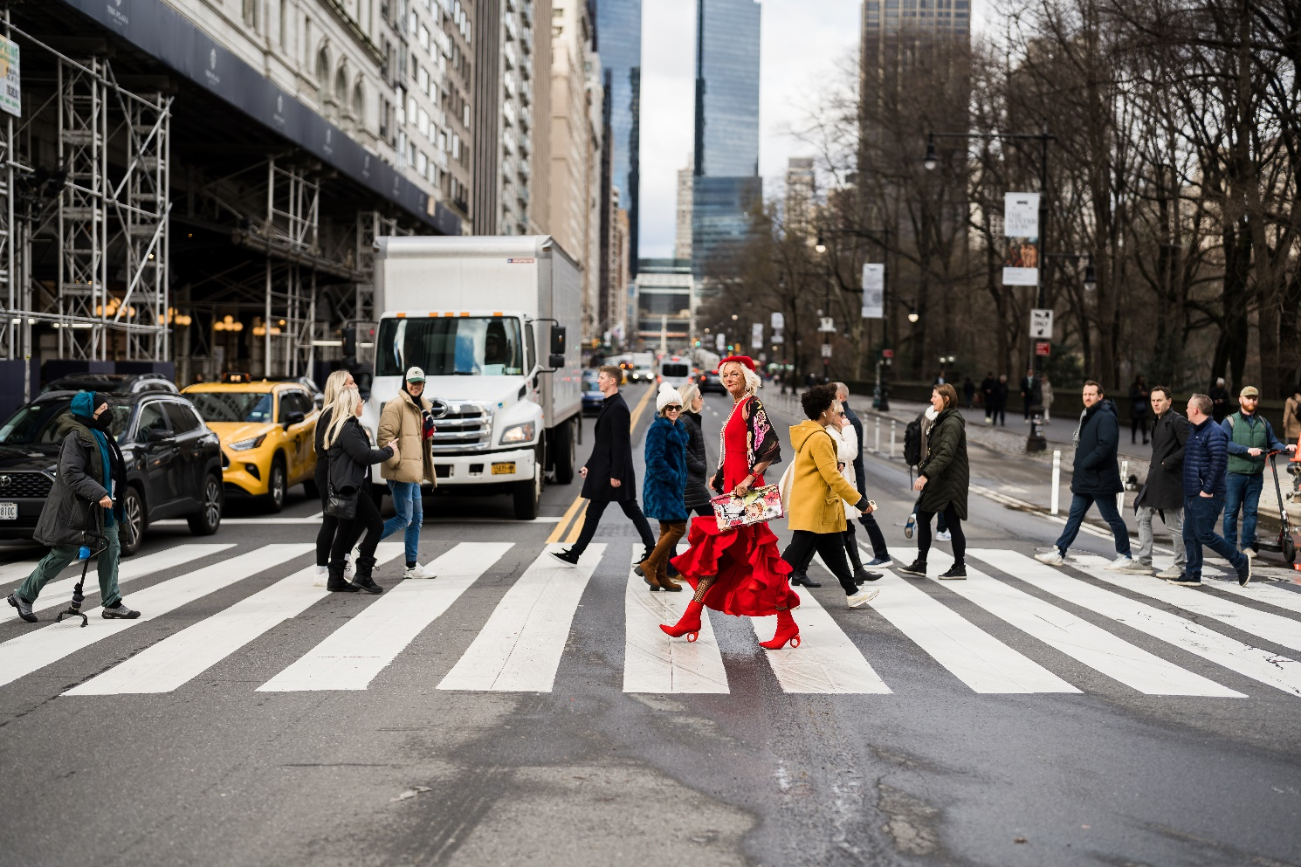

**NYC BIG APPLE PACKAGE**

**$7,595**

INCLUDES:

2 TICKETS NYC PLAZA GALA GRAND BALLROOM, BLACK TIE COCTAIL PARTY, FORMAL SIT DOWN DINNER, AWARD CEREMONY AND ENTERTAINMENT

2 NIGHTS PARK LANE HOTEL DEC 1-DEC 3

NYC TIMES SQUARE BILLBOARD DEBUT ON NASDAQ FRI DEC 1ST

PHOTOSHOOT WITH CARLOS

RED CARPET PHOTOS

FULL PAGE GALA MAGAZINE

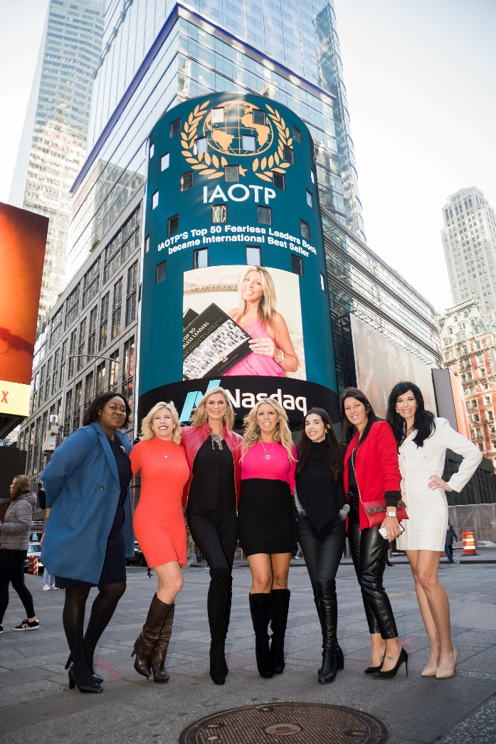

**GLAM PACKAGE WITH BILLBOARD**

**$7,595**

INCLUDES:

1 TICKET NYC PLAZA GALA GRAND BALLROOM, BLACK TIE COCTAIL PARTY, FORMAL SIT DOWN DINNER, AWARD CEREMONY AND ENTERTAINMENT

2 NIGHTS PARK LANE HOTEL DEC 1-DEC 3

NYC TIMES SQUARE BILLBOARD DEBUT ON NASDAQ

PHOTOSHOOT WITH CARLOS

RED CARPET PHOTOS

FULL PAGE GALA MAGAZINE

FRIDAY DECEMBER 1 -SUNDAY DECEMBER 3RD

FULL GLAM MAKEUP BY PROFESSIONAL MAKE UP ARTIST TO GET YOU RED CARPET GALA READY

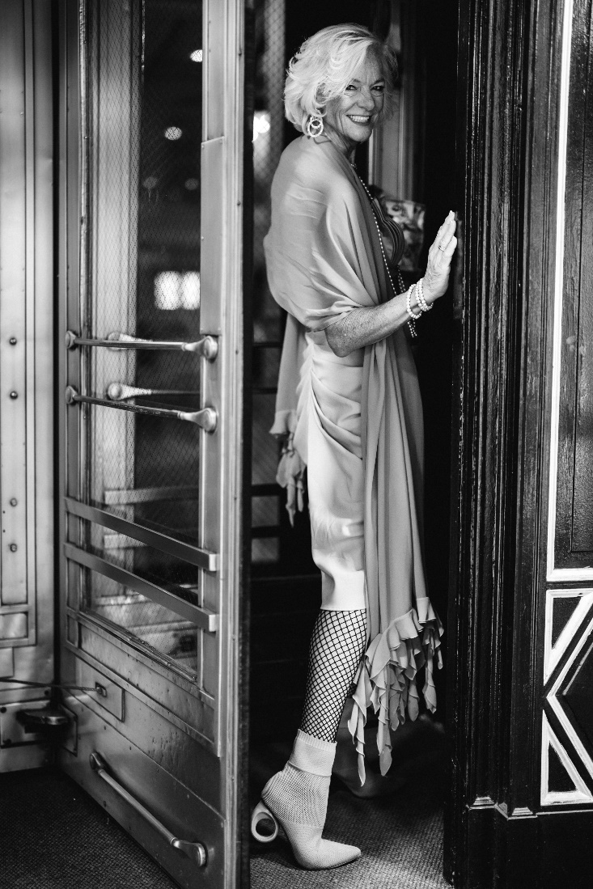

**GLAM PACKAGE WITHOUT BILLBOARD**

**$4,995**

INCLUDES:

1 TICKET NYC PLAZA GALA GRAND BALLROOM, BLACK TIE COCTAIL PARTY, FORMAL SIT DOWN DINNER, AWARD CEREMONY AND ENTERTAINMENT

2 NIGHTS PARK LANE HOTEL DEC 1-DEC 3

PHOTOSHOOT WITH CARLOS

RED CARPET PHOTOS

FULL PAGE GALA MAGAZINE

FRIDAY DECEMBER 1 -SUNDAY DECEMBER 3RD

FULL GLAM MAKEUP BY PROFESSIONAL MAKE UP ARTIST TO GET YOU RED CARPET GALA READY

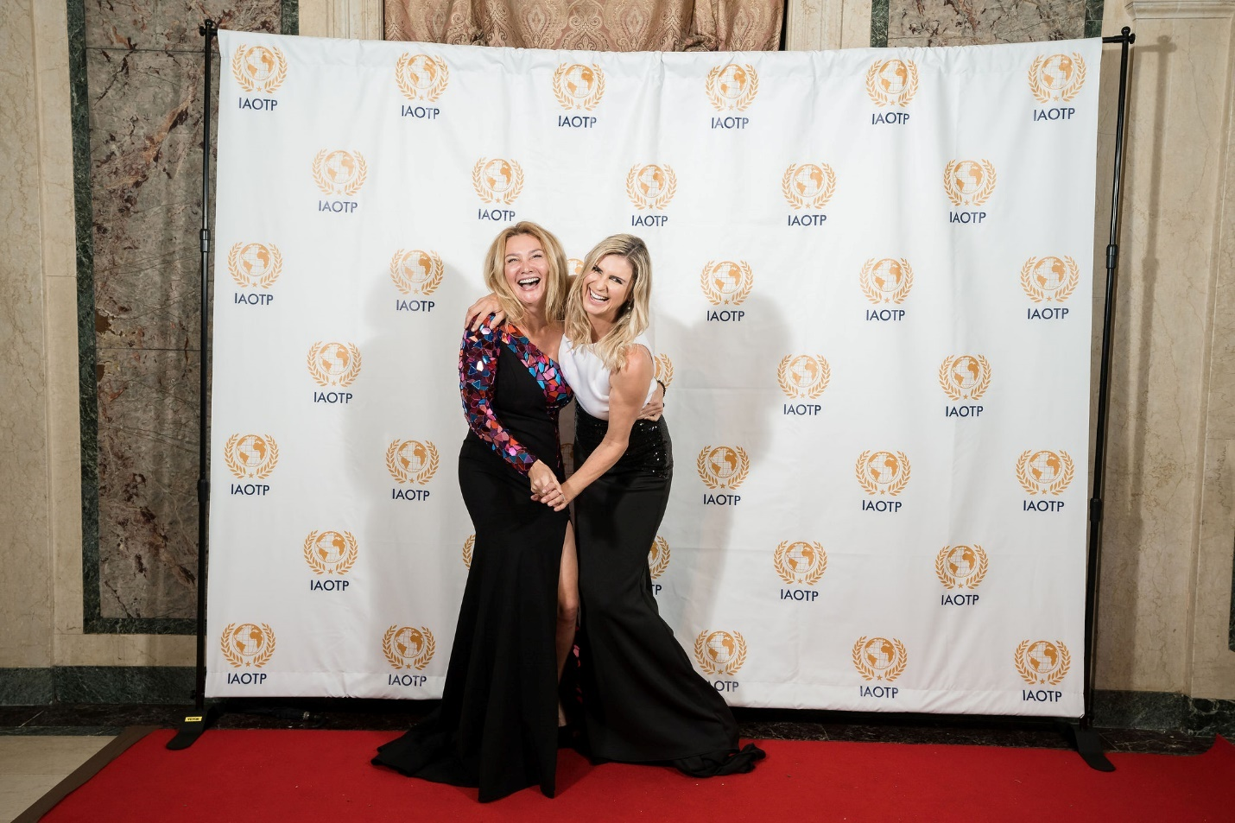

**PARTY GALA PACKAGE FOR 2**

**$3399 PARK LANE $4999 FOR PLAZA HOTEL**

INCLUDES:

2 TICKETS TO THE GALA

2 NIGHTS AT EITHER PLAZA HOTEL OR PARK LANE FRIDAY TO SUNDAY

FRIDAY DECEMBER 1ST -SUNDAY DECEMBER 3RD

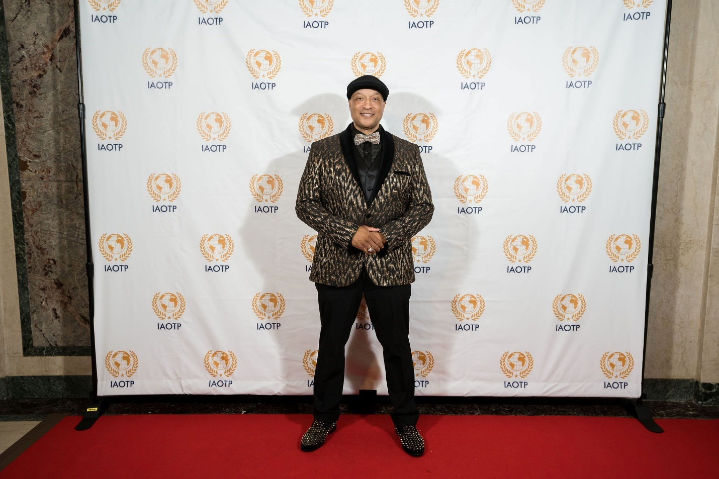

**PARTY GALA PACKAGE FOR 1**

**$2599 PARK LANE $4199 PLAZA HOTEL**

1 TICKET TO THE GALA

2 NIGHTS AT EITHER PLAZA HOTEL OR PARK LANE FRIDAY TO SUNDAY

FRIDAY DECEMBER 1ST -SUNDAY DECEMBER 3RD

***CANNOT FIND WHAT YOU ARE LOOKING FOR?***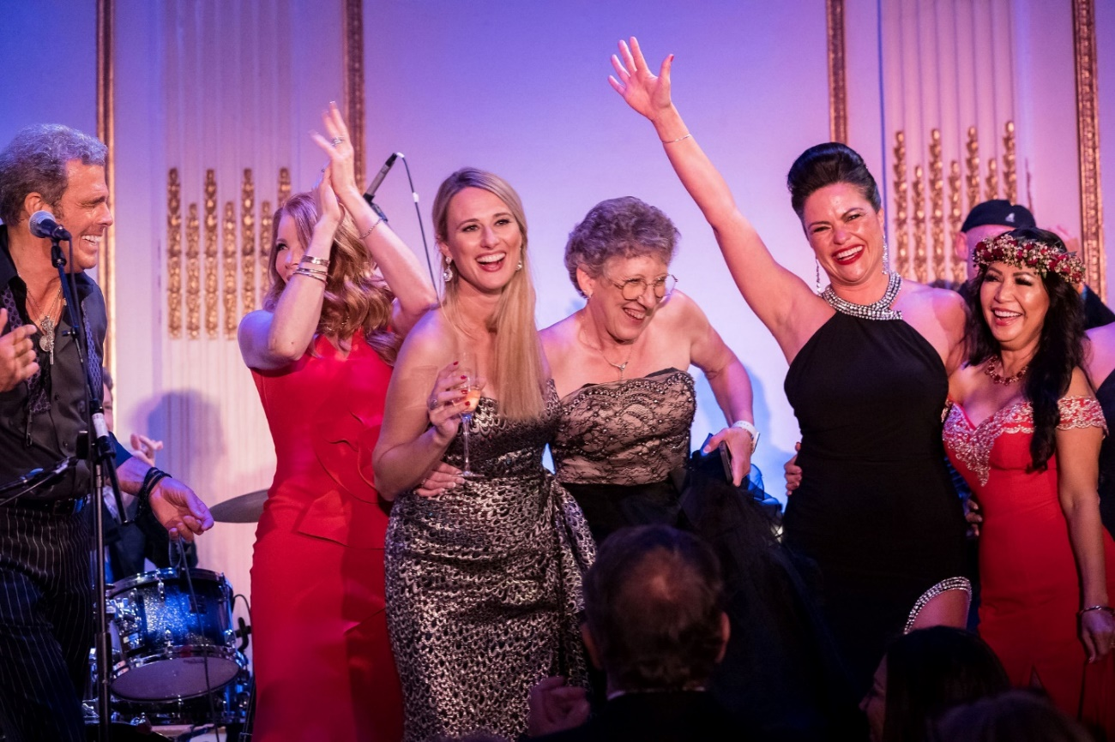

***CALL YOUR BRANDING EXECUTIVE TO CUSTOMIZE YOUR PERFECT VACATION PACKAGE TO COMMEMORATE THIS ACHIEVEMENT***

***212 634 4427***

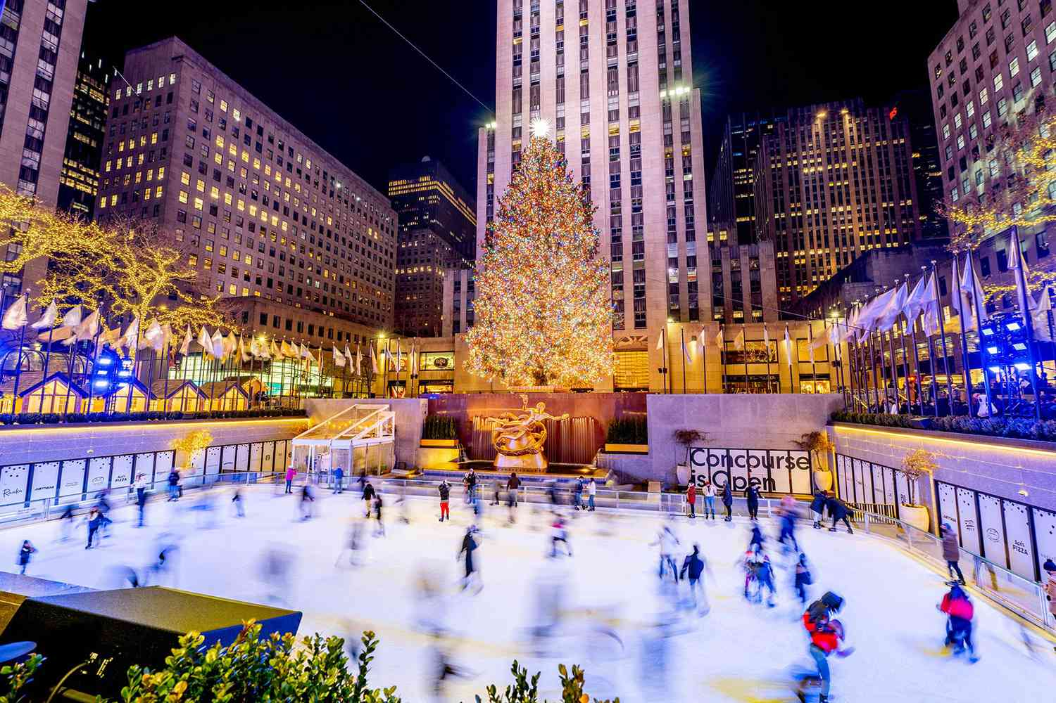

***ENJOY NYC***

***SEE YOU AT THE GALA!***